Rocket Principles

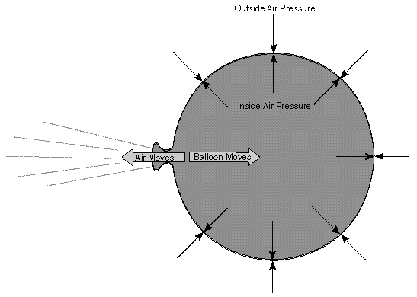
A rocket in its simplest form is a chamber enclosing a gas under pressure. A small opening at one end of the chamber allows the gas to escape, and in doing so provides a thrust that propels the rocket in the opposite direction. A good example of this is a balloon. Air inside a balloon is compressed by the balloon's rubber walls. The air pushes back so that the inward and outward pressing forces balance. When the nozzle is released, air escapes through it and the balloon is propelled in the opposite direction.
When we think of rockets, we rarely think of balloons. Instead, our attention is drawn to the giant vehicles that carry satellites into orbit and spacecraft to the Moon and planets. Nevertheless, there is a strong similarity between the two. The only significant difference is the way the pressurized gas is produced. With space rockets, the gas is produced by burning propellants that can be solid or liquid in form or a combination of the two.
One of the interesting facts about the historical development of rockets is that while rockets and rocket-powered devices have been in use for more than two thousand years, it has been only in the last three hundred years that rocket experimenters have had a scientific basis for understanding how they work.
The science of rocketry began with the publishing of a book in 1687 by the great English scientist Sir Isaac Newton. His book, entitled Philosophiae Naturalis Principia Mathematica, described physical principles in nature. Today, Newton's work is usually just called the Principia. In the Principia, Newton stated three important scientific principles that govern the motion of all objects, whether on Earth or in space. Knowing these principles, now called Newton's Laws of Motion, rocketeers have been able to construct the modern giant rockets of the 20th century such as the Saturn 5 and the Space Shuttle. Here now, in simple form, are Newton's Laws of Motion.
- Objects at rest will stay at rest and objects in motion will stay in motion in a straight line unless acted upon by an unbalanced force.
- Force is equal to mass times acceleration.
- For every action there is always an opposite and equal reaction.
As will be explained shortly, all three laws are really simple statements of how things move. But with them, precise determinations of rocket performance can be made.

Newton's First Law
This law of motion is just an obvious statement of fact, but to know what it means, it is necessary to understand the terms rest, motion, and unbalanced force.
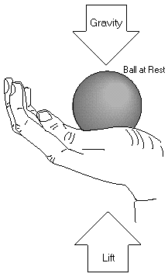
Rest and motion can be thought of as being opposite to each other. Rest is the state of an object when it is not changing position in relation to its surroundings. If you are sitting still in a chair, you can be said to be at rest. This term, however, is relative. Your chair may actually be one of many seats on a speeding airplane. The important thing to remember here is that you are not moving in relation to your immediate surroundings. If rest were defined as a total absence of motion, it would not exist in nature. Even if you were sitting in your chair at home, you would still be moving, because your chair is actually sitting on the surface of a spinning planet that is orbiting a star. The star is moving through a rotating galaxy that is, itself, moving through the universe. While sitting "still," you are, in fact, traveling at a speed of hundreds of kilometers per second.
Motion is also a relative term. All matter in the universe is moving all the time, but in the first law, motion here means changing position in relation to surroundings. A ball is at rest if it is sitting on the ground. The ball is in motion if it is rolling. A rolling ball changes its position in relation to its surroundings. When you are sitting on a chair in an airplane, you are at rest, but if you get up and walk down the aisle, you are in motion. A rocket blasting off the launch pad changes from a state of rest to a state of motion.
The third term important to understanding this law is unbalanced force. If you hold a ball in your hand and keep it still, the ball is at rest. All the time the ball is held there though, it is being acted upon by forces. The force of gravity is trying to pull the ball downward, while at the same time your hand is pushing against the ball to hold it up. The forces acting on the ball are balanced. Let the ball go, or move your hand upward, and the forces become unbalanced. The ball then changes from a state of rest to a state of motion.
In rocket flight, forces become balanced and unbalanced all the time. A rocket on the launch pad is balanced. The surface of the pad pushes the rocket up while gravity tries to pull it down. As the engines are ignited, the thrust from the rocket unbalances the forces, and the rocket travels upward. Later, when the rocket runs out of fuel, it slows down, stops at the highest point of its flight, and then falls back to Earth.
Objects in space also react to forces. A spacecraft moving through the solar system is in constant motion. The spacecraft will travel in a straight line if the forces on it are in balance. This happens only when the spacecraft is very far from any large gravity source such as Earth or the other planets and their moons. If the spacecraft
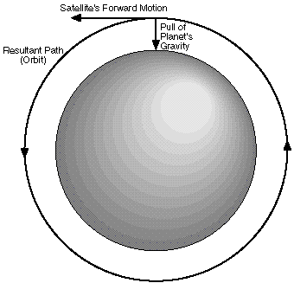
The combination of a satellite's forward motion and the pull of gravity of the planet, bend the satellite's path into an orbit.
comes near a large body in space, the gravity of that body will unbalance the forces and curve the path of the spacecraft. This happens, in particular, when a satellite is sent by a rocket on a path that is tangent to the planned orbit about a planet. The unbalanced gravitational force causes the satellite's path to change to an arc. The arc is a combination of the satellite's fall inward toward the planet's center and its forward motion. When these two motions are just right, the shape of the satellite's path matches the shape of the body it is traveling around. Consequently, an orbit is produced. Since the gravitational force changes with height above a planet, each altitude has its own unique velocity that results in a circular orbit. Obviously, controlling velocity is extremely important for maintaining the circular orbit of the spacecraft. Unless another unbalanced force, such as friction with gas molecules in orbit or the firing of a rocket engine in the opposite direction, slows down the spacecraft, it will orbit the planet forever.
Now that the three major terms of this first law have been explained, it is possible to restate this law. If an object, such as a rocket, is at rest, it takes an unbalanced force to make it move. If the object is already moving, it takes an unbalanced force, to stop it, change its direction from a straight line path, or alter its speed.

Newton's Third Law
For the time being, we will skip the Second Law and go directly to the Third. This law states that every action has an equal and opposite reaction. If you have ever stepped off a small boat that has not been properly tied to a pier, you will know exactly what this law means.
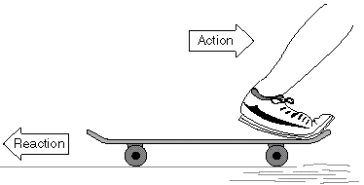
A rocket can liftoff from a launch pad only when it expels gas out of its engine. The rocket pushes on the gas, and the gas in turn pushes on the rocket. The whole process is very similar to riding a skateboard. Imagine that a skateboard and rider are in a state of rest (not moving). The rider jumps off the skateboard. In the Third Law, the jumping is called an action. The skateboard responds to that action by traveling some distance in the opposite direction. The skateboard's opposite motion is called a reaction. When the distance traveled by the rider and the skateboard are compared, it would appear that the skateboard has had a much greater reaction than the action of the rider. This is not the case. The reason the skateboard has traveled farther is that it has less mass than the rider. This concept will be better explained in a discussion of the Second Law.
With rockets, the action is the expelling of gas out of the engine. The reaction is the movement of the rocket in the opposite direction. To enable a rocket to lift off from the launch pad, the action, or thrust, from the engine must be greater than the weight of the rocket. While on the pad the weight of the rocket is balanced by the force of the ground pushing against it. Small amounts of thrust result in less force required by the ground to keep the rocket balanced. Only when the thrust is greater than the weight of the rocket does the force become unbalanced and the rocket lifts off. In space where unbalanced force is used to maintain the orbit, even tiny thrusts will cause a change in the unbalanced force and result in the rocket changing speed or direction.
One of the most commonly asked questions about rockets is how they can work in space where there is no air for them to push against. The answer to this question comes from the Third Law. Imagine the skateboard again. On the ground, the only part air plays in the motions of the rider and the skateboard is to slow them down. Moving through the air causes friction, or as scientists call it, drag. The surrounding air impedes the action-reaction.
As a result rockets actually work better in space than they do in air. As the exhaust gas leaves the rocket engine it must push away the surrounding air; this uses up some of the energy of the rocket. In space, the exhaust gases can escape freely.

Newton's Second Law
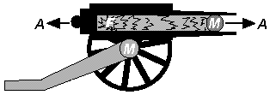
This law of motion is essentially a statement of a mathematical equation. The three parts of the equation are mass (m), acceleration (a), and force (f). Using letters to symbolize each part, the equation can be written as follows:
f = ma
The equation reads: force equals mass times acceleration. To explain this law, we will use an old style cannon as an example.
When the cannon is fired, an explosion propels a cannon ball out the open end of the barrel. It flies a kilometer or two to its target. At the same time the cannon itself is pushed backward a meter or two. This is action and reaction at work (Third Law). The force acting on the cannon and the ball is the same. What happens to the cannon and the ball is determined by the Second Law. Look at the two equations below.
f = m_{(cannon)} a_{(cannon)}
f = m_{(ball)} a_{(ball)}
The first equation refers to the cannon and the second to the cannon ball. In the first equation, the mass is the cannon itself and the acceleration is the movement of the cannon. In the second equation the mass is the cannon ball and the acceleration is its movement. Because the force (exploding gun powder) is the same for the two equations, the equations can be combined and rewritten below.
m_{(cannon)} a_{(cannon)} = m_{(ball)} a_{(ball)}
In order to keep the two sides of the equations equal, the accelerations vary with mass. In other words, the cannon has a large mass and a small acceleration. The cannon ball has a small mass and a large acceleration.
Apply this principle to a rocket. Replace the mass of the cannon ball with the mass of the gases being ejected out of the rocket engine. Replace the mass of the cannon with the mass of the rocket moving in the other direction. Force is the pressure created by the controlled explosion taking place inside the rocket's engines. That pressure accelerates the gas one way and the rocket the other.
Some interesting things happen with rockets that do not happen with the cannon and ball in this example. With the cannon and cannon ball, the thrust lasts for just a moment. The thrust for the rocket continues as long as its engines are firing. Furthermore, the mass of the rocket changes during flight. Its mass is the sum of all its parts. Rocket parts include: engines, propellant tanks, payload, control system, and propellants. By far, the largest part of the rocket's mass is its propellants. But that amount constantly changes as the engines fire. That means that the rocket's mass gets smaller during flight. In order for the left side of our equation to remain in balance with the right side, acceleration of the rocket has to increase as its mass decreases. That is why a rocket starts off moving slowly and goes faster and faster as it climbs into space.
Newton's Second Law of Motion can be restated in the following way: the greater the mass of rocket fuel burned, and the faster the gas produced can escape the engine, the greater the thrust of the rocket.

Putting Newton's Laws of Motion Together
An unbalanced force must be exerted for a rocket to lift off from a launch pad or for a craft in space to change speed or direction (First Law). The amount of thrust (force) produced by a rocket engine will be determined by the rate at which the mass of the rocket fuel burns and the speed of the gas escaping the rocket (Second Law). The reaction, or motion, of the rocket is equal to and in the opposite direction of the action, or thrust, from the engine (Third Law).

Name:
Date:
Rocket Principles

Directions: Answer the following questions as you read the article

Introduction
- What is a rocket in its simplest form?
- How does a rocket produce thrust?
- What is the significant difference between a rocket and a balloon?
- What are the two forms of propellants rockets use?
- What are Newton’s three laws of motion?

Newton’s First Law
- What is “rest” according to Newton’s first law?
- What is important to remember about rest?
- What is “motion” according to Newton’s first law?
- What does “an unbalanced force” mean?
- How do rockets unbalance the forces acting on them?
- What direction will a spacecraft travel if its forces are balanced?
- How are orbits produced?

Newton’s Third Law
- Why do you think the object with less mass will travel further than the object with more mass?
- How do rockets produce an “action”?
- Why must the force of thrust from the rocket be greater than its weight?
- Why do rockets work better in space than they do in air?
Newton’s Second Law
- What is the equation for Newton’s second law?
- How does the THIRD law influence a cannon when it’s fired?
- Why is the acceleration different for the cannon and the cannon ball?
- How does Newton’s second law apply to a rocket?
- How is the thrust acting on a rocket different from the thrust acting on a cannon ball?
- How does the mass of a rocket change during flight?

Putting Newton’s Laws of Motion Together
- How does the first law apply to rockets?
- How does the second law apply to rockets?
- How does the third law apply to rockets?

