The Three Estates

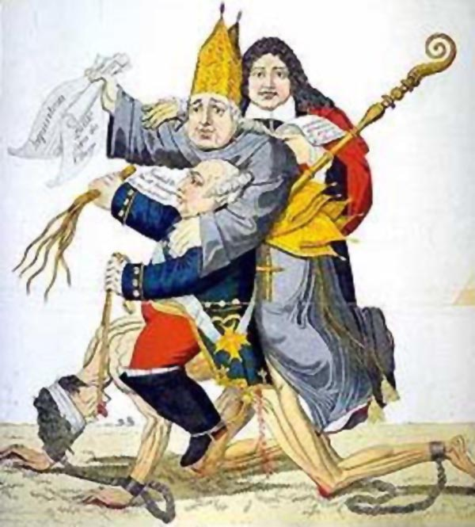

Before the revolution the French people were divided into 3 groups: the 1st estate consisted of the clergy, the second estate of the nobility and the third estate of the bourgeoisie, urban workers, and peasants. Legally the first two estates enjoyed many privileges, particularly exemption from most taxation.

The First Estate consisted of the high nobility and the clergy. They owned about 10% of the land, made up about 1% of the population and paid 0% of the taxes.

The Second Estate consisted of the middle nobility, military, government officials, clergy and courts. They owned about 30% of the land, made up about 2 percent of the population and paid 0% of the taxes.

The Third Estate consisted of the merchants, peasants, serfs, laborers, artisans and other commoners. They owned about 40% of the land, made up about 97% of the population and paid 100% of the taxes.

Financial Crisis

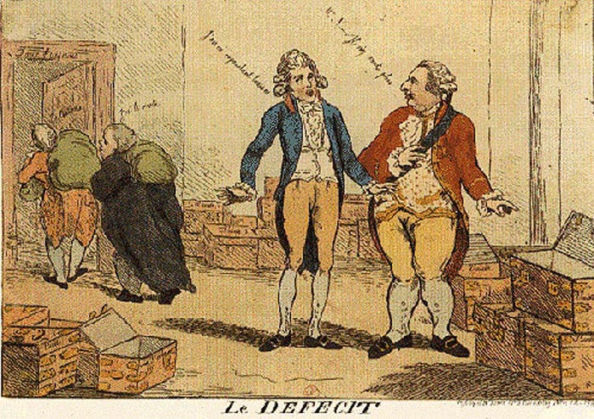

*In this cartoon from the time, Louis is looking at the chests and asks "where is the tax money?"*

While the King and Queen of France lived in luxury and splendor at the magnificent Palace of Versailles outside of Paris, the government of France, was bankrupt and was facing a serious financial crisis.

The crisis came about primarily because of an inefficient and unfair tax structure, outdated medieval bureaucratic institutions, and a drained treasury which was the result of aiding the Americans during the American Revolution, long wars with England and throughout Europe, overspending, and an inequitable tax system which placed the burden of taxation on those least able to pay, the Third Estate.

Social Stagnation

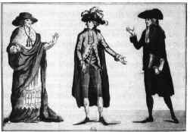

*The Three Estates*

The three estates in pre-revolutionary France functioned very much like a caste system. There was not a great deal of social mobility. People were born a noble and died a noble, they were born a peasant and died a peasant. The only group with any chance at social mobility was the merchants.

Merchants were occasionally wealthy and as a result were sometimes able to afford an education and become employed in government service. While this was normally reserved for the nobles, merchants were able to exert a small influence though not one large enough to have a substantial impact.

Unequal Political System

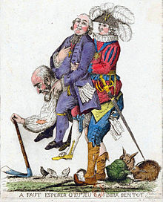

In the French political system not everybody had a say. The third estate was commonly left out entirely from any role in government whatsoever. Apart from the voices of a few lucky merchants who managed to fight their way into politics, this group was ignored. They were merely expected to work, pay taxes and accept the decisions made by the King and government officials.

Louis XIV worked very hard to decrease the amount of influence the nobility had in government. He embraced the mentality ‘keep your friends close and your enemies closer.’ For Louis XIV this meant nobles who would plot against him and try to take away his power.

Competing Ideologies

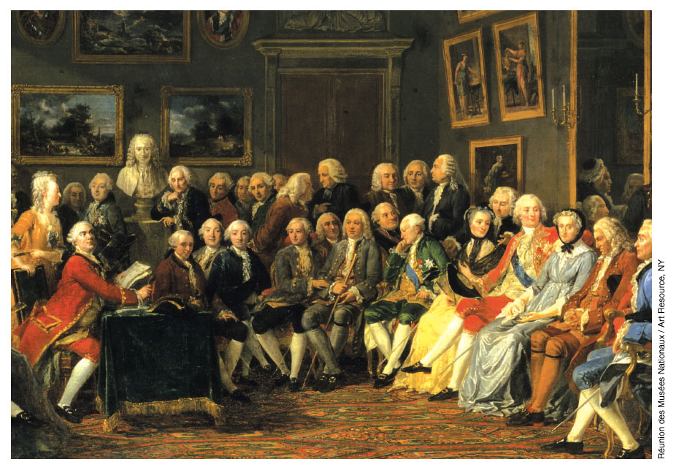

*Philosophes in a Salon*

As philosophes (intellectuals during the age of enlightenment) examined the society they saw around them they began to ask questions about the nature of that society. How did it function? What rules governed it? What is the role of government? How should men and women be governed? What is the nature of law? What is the relationship between the governor and the governed?

These questions challenged absolutism and brought conflicting ideas into the political and social sphere. As people began to read more they discussed these ideas, this caused them to begin to question the French monarchy.

The Estates General

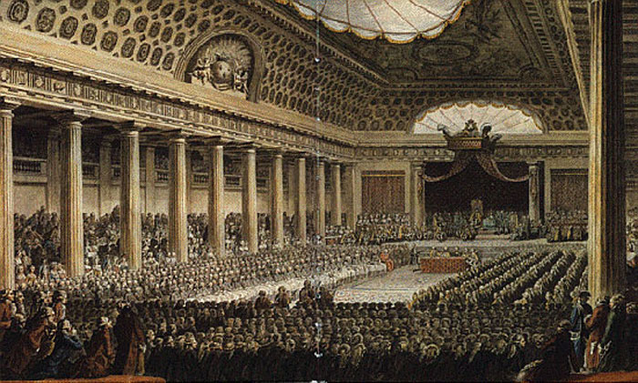

*The meeting of the Estates General May 5, 1789*

Due to the growing economic problems, social unrest, mounting tension between the upper and lower classes, and frustrations of the nobility Louis XVI is forced to call the Estates General in 1788. The Estates General was a form of French Parliament whereby representatives from the three estates would gather together to decide on policy issues, national direction, and other governmental matters.

The delegates of the[third estate](http://www.historywiz.com/oldregime.htm) insisted that the three orders meet together and that the vote be taken by head, rather than by order. (Since there were far more delegates from the third estate, this plan would give them a majority). The King refused to grant their request. The third estate refused to budge.

The Bourgeoisie Revolt

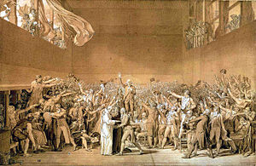

"[What is the Third Estate](http://www.historywiz.com/primarysources/abbesieyes.htm)?" wrote Abbe Sieyes. "It is everything!" This liberal clergyman rallied the commoners of France to assert their power and take charge of the [Estates General](http://www.historywiz.com/estatesgeneral.htm). Finally at his suggestion, they declared themselves the National Assembly and invited the other two orders to join them. The next day they found their meeting hall locked. At the suggestion of one of the delegates they moved to a nearby indoor tennis court, where they swore the [Tennis Court Oath](http://www.historywiz.com/tenniscourt.htm).

The King had declared the activities of the Third Estate illegal and refused to recognize the "National Assembly."  Meeting in defiance at an indoor tennis court at Versailles, the Third Estate swore not to separate until a constitution had been written for France. Only one delegate dissented. Their oath is known as the [Tennis Court Oath](http://www.historywiz.com/primarysources/tenniscourtoathtext.htm).

Hearing of the oath, the King called a meeting of all three orders. At the end of the meeting he ordered the Third Estate to disperse. They refused. One of the delegates declared that  "We are here at the will of the people, . . . and . . . shall not stir from our seats unless forced to do so by bayonets." The King was unwilling to use force and eventually ordered the first and second estates to join the new National Assembly. The Third Estate had won.

Equality for All

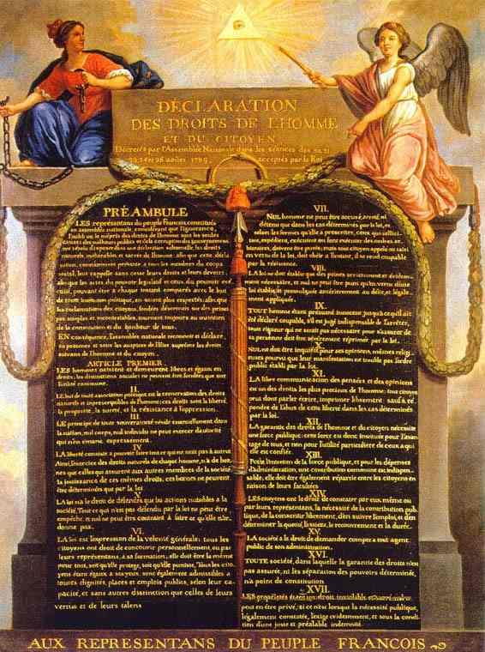

*The Declaration for the Rights of Man and the Citizen*

On August 26, 1789 the National Assembly writes and publishes the Declaration for the Rights of Man and the Citizen. This document draws upon the United States Declaration of Independence, the Constitution and the English Bill of Rights. It endorses the enlightenment ideals of liberty, freedom from oppression, security and property.

Earlier that month the National Assembly voted to remove many of the rights and privileges enjoyed by the first and second estates. This document further reinforced that decision.

Storming the Bastille

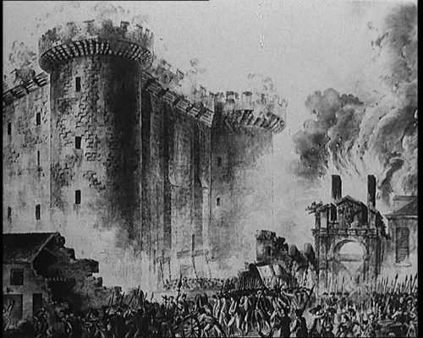

The Bastille was a medieval fortress with 8 towers, which at the time of the French Revolution housed only a few common criminals. But because it had previously been used to house political prisoners, it had long been a symbol of royal tyranny. Cardinal Richelieu, acting for King Louis XIII, had imprisoned enemies of the king. Prisoners were arrested by a secret warrant issued by the King called a lettres-de-cachet. They were not given a trial, nor informed of the charges, but simply held in secret. If they were released they were instructed not to reveal anything they had seen or experienced inside the prison. This was long before the reign of Louis XVI, but the mystique of secrecy and terror made it a focus of the anger of the Parisian mob.

On July 14, 1789 a mob of Parisians attack the Bastille, free the few prisoners they found inside and tear it apart brick by brick. Because it was seen as a symbol of the absolute monarch’s power its destruction demonstrated people’s frustration with the regime.

Solving Problems

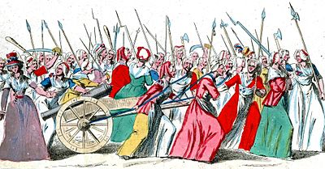

On October 4, 1789, a crowd of women demanding bread for their families gathered other discontented Parisians, including some men, and marched toward Versailles, arriving soaking wet from the rain. They demanded to see "the Baker," "the Baker's wife," and "the Baker's boy". The King agreed to meet with some of the women and promised to distribute all the bread in [Versailles](http://www.historywiz.com/royalty.htm) to the crowd. He addressed the people from his balcony when threatened with being forced to return to Paris. "My friends," he said, "I will go to Paris with my wife and my children." It was a fatal mistake. It was the last time the King saw Versailles.

The National Assembly resolved the immediate financial crisis by seizing church lands and in [The Civil Constitution of the Clergy](http://www.historywiz.com/primarysources/civilconstitution.htm)putting the church under the control of the State. [Abbe Sieyes](http://www.historywiz.com/primarysources/abbesieyes.htm) fiercely resisted the passage of this legislation and accused the other delegates of "bourgeois envy." But he was overruled. The measure was very controversial to a nation of Catholics and drew support away from the new government. This legislation (and legislation immediately before and after it) significantly reduced the power of the Catholic Church.

The Constitution of 1791

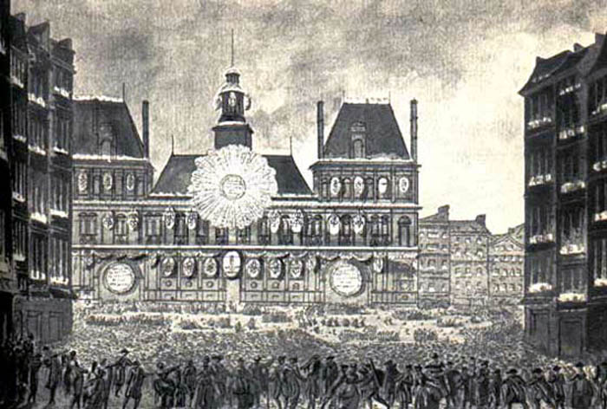

*Proclamation of the Constitution of 1791*

The new constitution created by these moderate revolutionaries declared France to be a constitutional monarchy. Within this new government, all legislative powers went to a single Legislative Assembly, which alone had the power to declare war and raise taxes.

The Legislative Assembly was an indirectly elected body. It was made up of representatives selected by Electors, who themselves were elected by "active" citizens. An active citizen was a male citizen who paid annual taxes equal to the local wages paid for three days of labor. About two thirds of the male citizens were able to vote. Only a small number qualified to serve as either electors or members of the Legislative Assembly.

The monarch had only limited powers. He could temporarily stop legislation with a *suspensive* *veto*, but he could not veto anything permanently. He had no control of the army, or any authority over local government. He had no voice in the new Legislative Assembly.

The constitution lasted only one year. Even as the constitution was created, the revolution was turning in a more radical direction.

Attack on the Tuileries

*Mob placing the red cap of liberty on the King's head at the Tuileries*

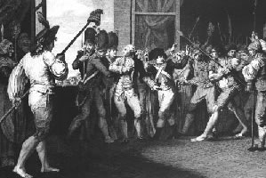

The royal family was living under house arrest in the Tuileries Palace. An angry mob got into the building on June 20, 1792, and found their way to the King.  The crowd shouted insults and were in an ugly mood. The King remained calm and obediently put on the red cap of liberty (a symbol of revolution) at the mob's insistence. When they thrust a bottle of wine at him he drank a toast to the health of the nation.

But he refused to change his position on the clergy. Under the [Constitution of 1791](http://www.historywiz.com/constitution1791.htm) (creating a constitutional monarchy) he had exercised his veto of a proposal to punish priests who refused to support the changes to the church. A religious man, the King felt it would violate his conscience to agree to the mob's demands.

This time the royal family barely escaped with their lives. The king's guards were killed and the King and his family fled to the protection of the Assembly. The constitutional monarchy was over.

The September Massacres

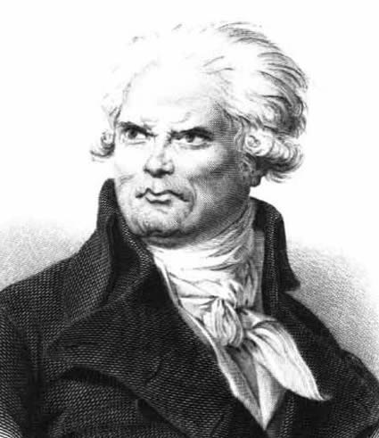

*Georges-Jacques Danton*

Georges-Jacques Danton, a revolutionary leader and a powerful orator, rose in the Assembly on September 2nd 1792 and boomed out these memorable words in his deep bass voice: *"When the tocsin sounds, it will not be a signal of alarm, but the signal to charge against the enemies of our country. . . To defeat them, gentlemen, we need boldness, and again boldness, and always boldness; and France will then be saved."*

Danton probably meant boldness in fighting the war against Austria. But many took his words to refer to enemies within France. The radical press took up the cry, "Let the blood of the traitors flow," and within hours of Danton's speech the streets of France did indeed run with blood. Many thought the prisons held counter-revolutionaries and so mobs of citizens invaded the prisons, held mock trials, and slaughtered many of the inmates. Many of the inmates were clergymen who had refused to swear the oath which they felt put the state over the Pope. By September 7, over 1000 were dead.

Execution of Louis XVI

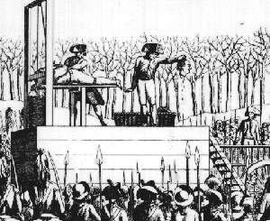

The constitutional monarchy put in place by moderate revolutionaries such as the Marquis de Lafayette had fallen by 1792, giving way to a radical republic. The National Convention decided to put Louis on trial for his crimes. Although his guilt was never an issue, there was a real debate in the Convention on whether the king should be killed. They voted for his execution. On January 23, 1793 Louis Capet went to the guillotine in the Place de la Concorde, where a statue of his predecessor, Louis XV, once stood.  At the scaffold he said "I forgive those who are guilty of my death."

Rise of the Jacobins

[*The Death of Marat by Jacques-Louis David*](http://www.historywiz.com/galleries/deathofmarat.html)

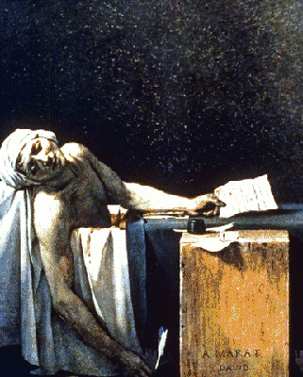

During the constitutional monarchy there were two radical groups vying for power, the Girondins and the Jacobins. During the [September massacres](http://www.historywiz.com/septembermass.htm) later that year, the Girondin leaders tried to persuade the crowds out of their bloody attacks. The Jacobins, who understood the Parisians better than the provincial Girondins, encouraged the violence. They continued to attack the feeble Girondins.

When Jean-Paul Marat, a Jacobin journalist who showed little regard for the truth, was arrested for attacking Girondins, the people of Paris turned even more toward the Jacobins.  The people loved Marat and he seemed to love them too. When he was acquitted of the charge, the crowds swarmed around him, scooped him up on their shoulders and carried him to the Convention, cheering all the way.

When the constitutional monarchy fell and the King was put on trial for treason in December, the Girondins argued against his execution. The Jacobins thought he needed to die to ensure the safety of the revolution. When the Jacobins were successful the tide turned against the Girondins. The Jacobins in the National Convention had 22 Girondin leaders arrested and executed. The Jacobins had won.

A final Girondin blow was struck, however, when Charlotte Corday, a Girondin sympathizer, gained entrance to Marat's bath and stabbed him. Marat immediately became a martyr to the revolution. He was given a hero's funeral and the procession lasted 7 hours.