Course: History of the Holocaust and Genocide
Teacher: Mr. Jobb
Classroom: 5
Phone: 608-361-4339
Email: jjobb@sdb.k12.wi.us

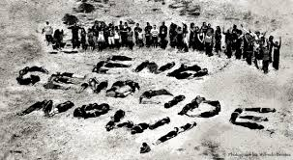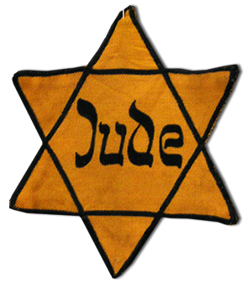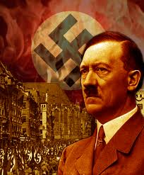

Course Description

The purpose of studying the Holocaust, arguably the most crucial event of the twentieth century, is to provide students with a solid appreciation of the need for the respect and tolerance of others. In this class we will analyze: anti-Semitism throughout history; the chronological developments that led to the Holocaust; and numerous personal accounts of survivors and of those who died at the hands of the Nazis; other groups persecuted by the Nazis apart from Jews; and other genocides that have occurred in modern history.
I recognize that students have a variety of learning styles and come from diverse backgrounds. Therefore, instruction will include many different approaches including: inquiry, Simulations, Cooperative Grouping, Critical Thinking, Experimental and individualized activities as well as traditional approaches.

Course Outline

Unit One: Genocide
- Pyramid of Hate
- 8 Steps of Genocide
- Examples of genocides besides the Holocaust

Unit Two: Judaism and Anti-Semitism
- Judaism Notes
- Jewish Stereotypes/Myths
- History of Anti-Semitism Notes

Unit Three: Hitler’s Rise to Power
- State of Germany After WWI
- Growing Up Hitler
- Hitler and the Nazis
- Totalitarian State of Germany

Unit Four: Propaganda
- Nazi Propaganda Notes
- Propaganda Techniques
- Hitler’s Use of Propaganda
- Poisonous Mushroom Book Activity

Unit Five: 1st and 2nd Solutions
- 1st Solution Notes
- Kristallnacht Accounts
- 2nd Solution Notes
- In My Hands Reading

Unit Six: The Final Solution
- Einsatzgruppen Notes/Simulation
- I Survived Rumbuli
- Final Solution Notes
- Reinhard Camps- Belzec, Sobibor, Treblinka
- Majdanek and Auschwitz Notes
- Auschwitz Accounts
- Camp Project
- Resistance and Conclusion Notes

