Image A

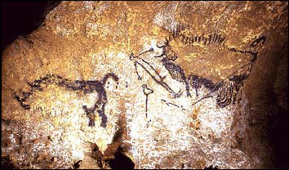

Shaft of the dead man. Lascaux, France.
20,000 Years Old.

Image B

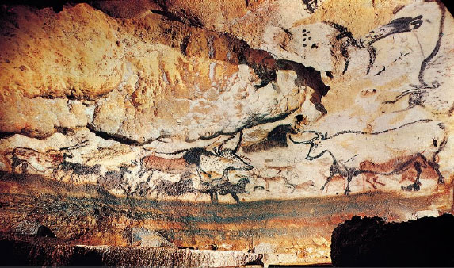

The Great Hall of the Bulls. Lascaux, France.
20,000 Years Old.

Image C

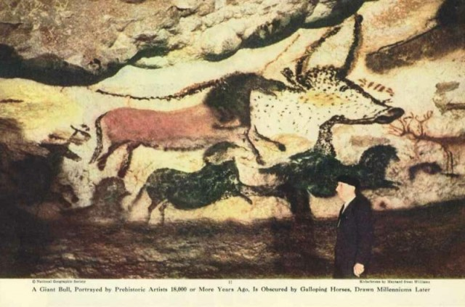

A Great Bull. Lascaux, France.
20,000 Years Old.

Image D

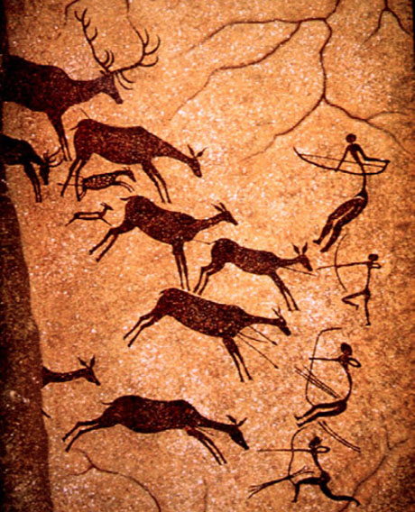

The Great Hall of Bulls. Lascaux, France.
20,000 Years Old.
Image E

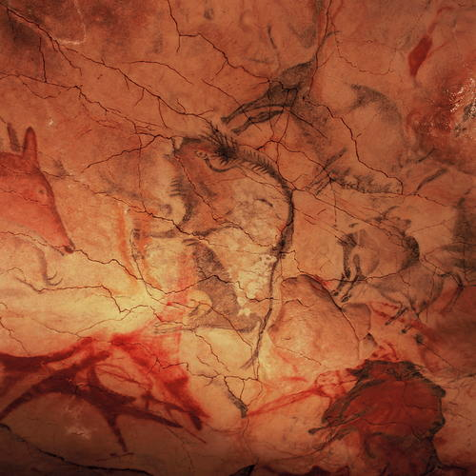

Altamira. Northern Spain.
14,000-22,000 Years Old.

Image F

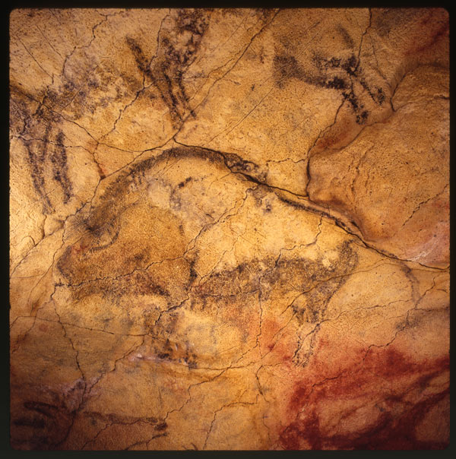

Altamira. Northern Spain.
14,000-22,000 Years Old.

Image G

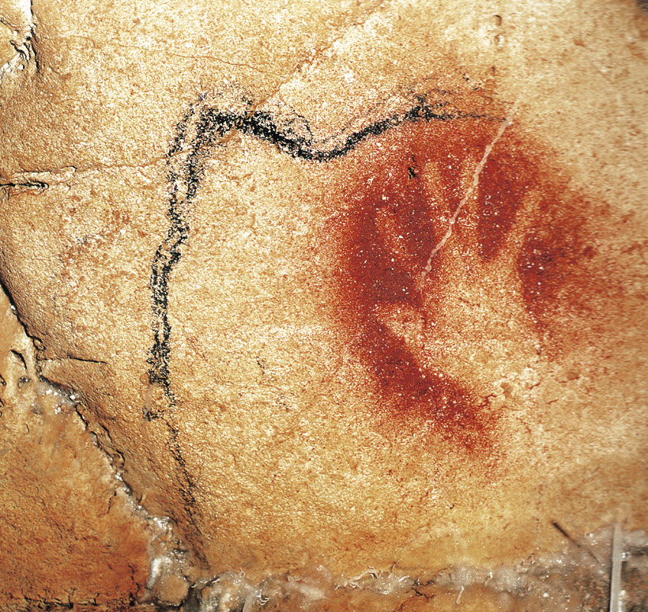

Red Hand. Chauvet, France.
30,000-33,000 Years Old.

Image H
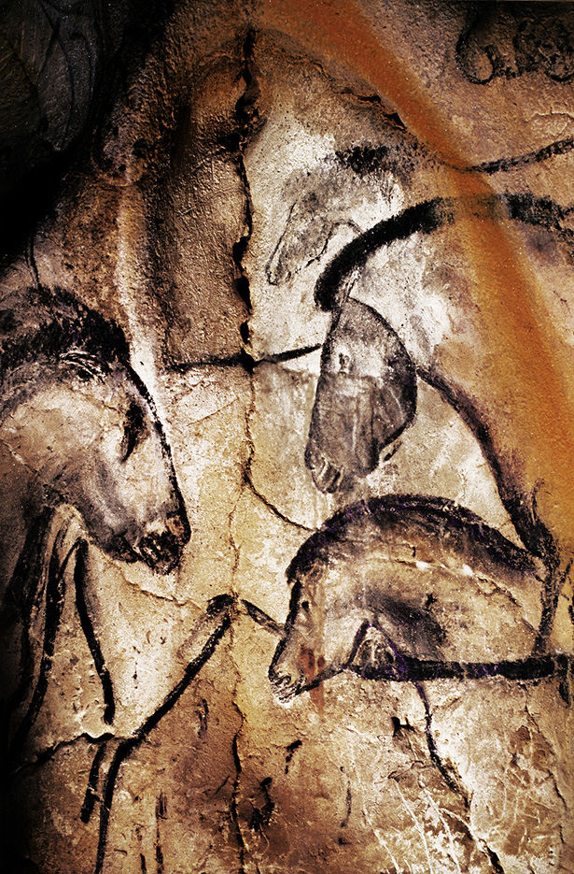

Facing Horses. Chauvet, France.
30,000-33,000 Years Old.
Image I

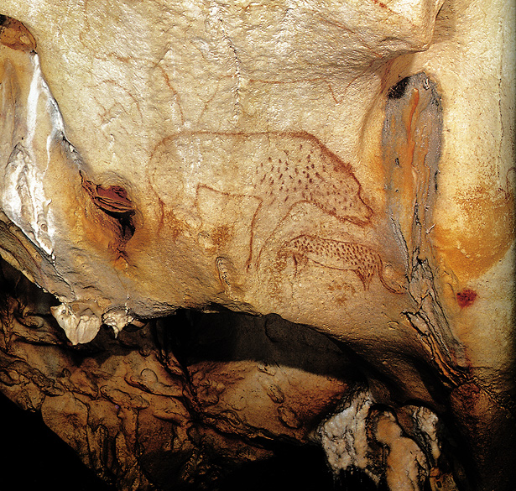

The Panther Panel. Chauvet, France.
30,000-33,000 Years Old.

Image J
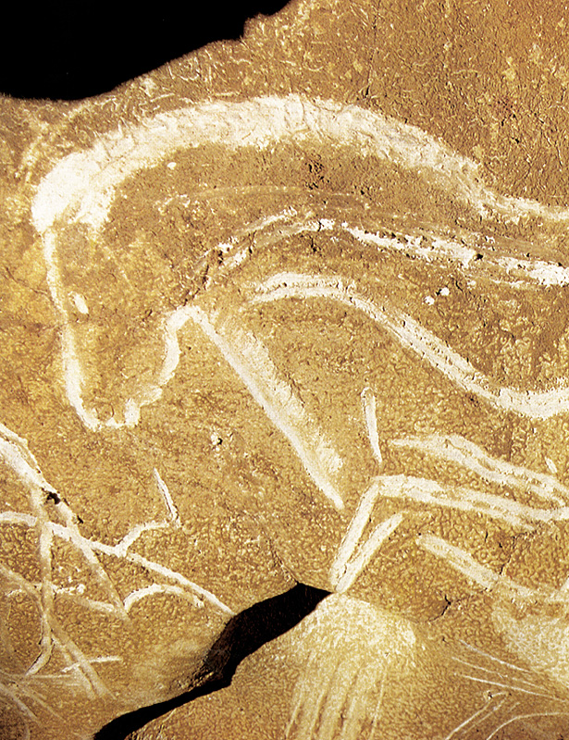

Large Horse Panel. Chauvet, France.
30,000-33,000 Years Old.
Image K

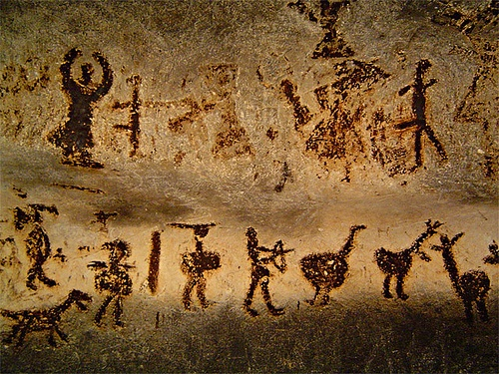

Magura Cave. North-western Bulgaria.
Approximately 15,000 Years Old.

Image L

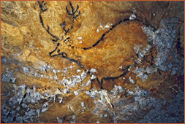

Cosquer, France
27,000 Years Old.

Image M

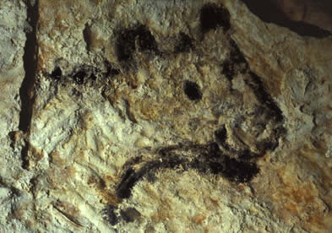

Cosquer, France.
27,000 Years Old.

Image N

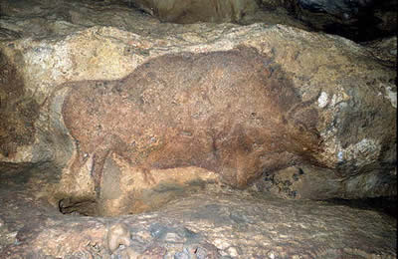

Font de Gaume. Dordogne Valley, France.
19,000 Years Old.

Image O

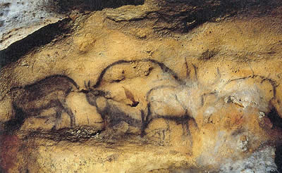

Font de Gaume. Dordogne Valley, France.
19,000 Years Old

