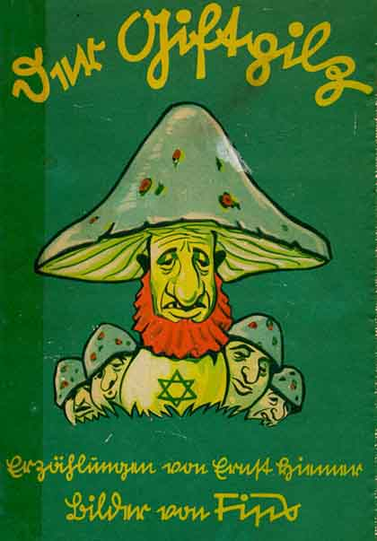

The Poisonous Mushroom

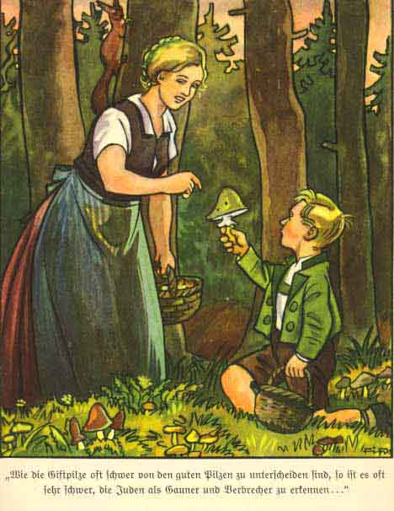
A mother and her young boy are gathering mushrooms in the German forest. The boy finds some poisonous ones. The mother explains that there are good mushrooms and poisonous ones, and, as they go home, says:
“Look, Franz, human beings in this world are like the mushrooms in the forest. There are good mushrooms and there are good people. There are poisonous, bad mushrooms and there are bad people. And we have to be on our guard against bad people just as we have to be on guard against poisonous mushrooms. Do you understand that?”
“Yes, mother,” Franz replies. “I understand that in dealing with bad people trouble may arise, just as when one eats a poisonous mushroom. One may even die!”
“And do you know, too, who these bad men are, these poisonous mushrooms of mankind?” the mother continued.
Franz slaps his chest in pride:
“Of course I know, mother! They are the Jews! Our teacher has often told us about them.”
The mother praises her boy for his intelligence, and goes on to explain the different kinds of “poisonous” Jews: the Jewish peddler, the Jewish cattle-dealer, the Kosher butcher, the Jewish doctor, the baptized Jew, and so on.
“However they disguise themselves, or however friendly they try to be, affirming a thousand times their good intentions to us, one must not believe them. Jews they are and Jews they remain. For our Volk they are poison.”
“Like the poisonous mushroom!” says Franz.
“Yes, my child! Just as a single poisonous mushrooms can kill a whole family, so a solitary Jew can destroy a whole village, a whole city, even an entire Volk.”
Franz has understood.
“Tell me, mother, do all Gentiles know that the Jew is as dangerous as a poisonous mushroom?”
Mother shakes her head.
“Unfortunately not, my child. There are millions of Gentiles who do not yet know the Jews. So we have to enlighten people and warn them against the Jews. Our young people, too, must be warned. Our boys and girls must learn to know the Jew. They must learn that the Jew is the most dangerous poison-mushroom in existence. Just as poisonous mushrooms spring up everywhere, so the Jew is found in every country in the world. Just as poisonous mushrooms often lead to the most dreadful calamity, so the Jew is the cause of misery and distress, illness and death.”
The author then concludes this story by pointing the moral:
German youth must learn to recognize the Jewish poison-mushroom. They must learn what a danger the Jew is for the German Volk and for the whole world. They must learn that the Jewish problem involves the destiny of us all.
“The following tales tell the truth about the Jewish poison-mushroom. They show the many shapes the Jew assumes. They show the depravity and baseness of the Jewish race. They show the Jew for what he really is:
The Devil in human form.

How To Tell A Jew

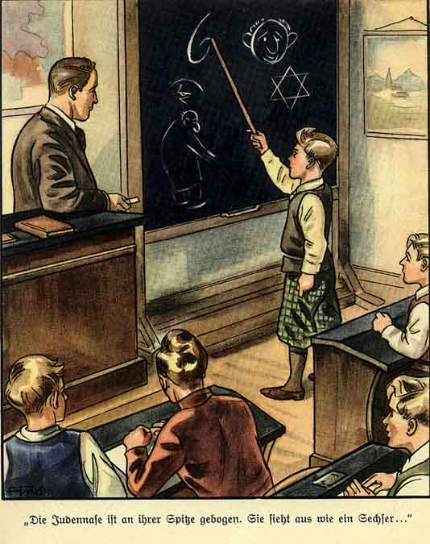
Things are lively in Mr. Birkmann’s 7th grade boys’ class today. The teacher is talking about the Jews. Mr. Birkmann has drawn pictures of Jews on the blackboard. The boys are fascinated. Even the laziest of them, “Emil the Snorer,” is paying attention, not sleeping, as he so often does during other subjects. Mr. Birkmann is a good teacher. All the children like him. They are happiest when he talks about the Jews. Mr. Birkmann can do that well. He learned about the Jews from life. He knows how to put it in gripping terms such that the favorite hour of the day is the “Jewish hour.” Mr. Birkmann looks at the clock.
“It is noon,” he says. “We should summarize what we have learned in the past hour. What have we talked about?”
All the children raise their hands. The teacher calls on Karl Scholz, a small lad in the front row. “We have talked about how to recognize the Jews.”
“Good. Say more!”
Little Karl reaches for the pointer, steps up to the board and points at the drawings.
“One can most easily tell a Jew by his nose. The Jewish nose is bent at its point. It looks like the number six. We call it the 'Jewish six.' Many Gentiles also have bent noses. But their noses bend upwards, not downwards. Such a nose is a hook nose or an eagle nose. It is not at all like a Jewish nose.”
“Right!” says the teacher. “But the nose is not the only way to recognize a Jew...”
The boy goes on. “One can also recognize a Jew by his lips. His lips are usually puffy. The lower lip often protrudes. The eyes are different too. The eyelids are mostly thicker and more fleshy than ours. The Jewish look is wary and piercing. One can tell from his eyes that he is a deceitful person.”
The teacher calls on another lad. He is Fritz Müller, and is the best in the class. He goes to the board and says:
“Jews are usually small to mid-sized. They have short legs. Their arms are often very short too. Many Jews are bow-legged and flat-footed. They often have a low, slanting forehead, a receding forehead. Many criminals have such a receding forehead. The Jews are criminals too. Their hair is usually dark and often curly like a Negro’s. Their ears are very large, and they look like the handles of a coffee cup.”
The teacher turns to the students.
“Pay attention, children. Why does Fritz always say ‘many Jews have bow legs’, or ‘they often have receding foreheads,’ or ‘their hair is usually dark’?”
Heinrich Schmidt, a large, strong boy in the last row speaks.
“Every Jew does not have these characteristics. Some do not have a proper Jewish nose, but real Jewish ears. Some do not have flat feet, but real Jewish eyes. Some Jews cannot be recognized at first glance. There are even some Jews with blond hair. If we want to be sure to recognize Jews, we must look carefully. But when one looks carefully, one can always tell it is a Jew.”
“Very good,” the teacher says. “And now tell me about other ways to tell Jews from Gentiles. Richard, come up here!”
Richard Krause, a smiling blond lad, goes to the board. He says: “One can recognize a Jew from his movements and behavior. The Jew moves his head back and forth. His gait is shuffling and unsteady. The Jew moves his hands when he talks. He “jabbers.” His voice is often odd. He talks through his nose. Jews often have an unpleasant sweetish odor. If you have a good nose, you can smell the Jews.”
The teacher is satisfied.
“That how it is, kids. You have paid attention! If you pay attention outside school and keep your eyes open, you won’t be fooled by the Jews.”
The teacher goes to the lectern and turns the board. On the other side a poem is written. The children read it out loud:
“From a Jew’s face
The wicked Devil speaks to us,
The Devil who, in every country,
Is known as an evil plague.
Would we from the Jew be free,
Again be cheeful and happy,
Then must youth fight with us
To get rid of the Jewish Devil.”

How the Jews Came to Us

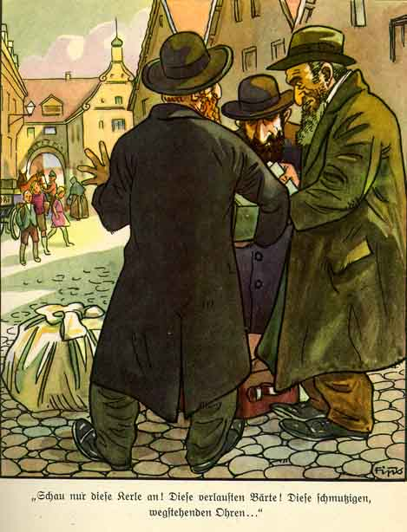
The scene of the next story is a small German town. School-children stop in the street to observe and comment on three “Eastern Jews.”
“Look at those creatures!” cries Fritz.
“Those sinister Jewish noses! Those lousy beards! Those dirty, standing-out ears! Those bent legs! Those flat feet! Those stained, fatty clothes! Look how they move their hands about! How they haggle! And those are supposed to be men!”
“And what sort of men?” replies Karl. “They are criminals of the worst sort.”
He describes their trafficking in wares and how, when they have money enough they
“Get rid of their dirty clothes, cut their beards off, de-louse themselves, put on up-to-date clothes and go about as if they were not Jews. In Germany they speak German and behave as though they were Germans. In France they speak French and act as Frenchmen. In Italy they want to be Italians; in Holland, Dutch; in America, Americans; and so on. So they carry on throughout the whole world.”
Fritz laughs at this and says anyhow they can always be recognized as Jews. Karl nods:
“Naturally, one can tell them if one uses one’s eyes. But unfortunately, there are still many who fall for the Jewish swindle.”
Fritz answers:
“Not me! I know the Jews! I know, too, a verse about them:
“Once they came from the East,
Dirty, lousy, without a cent;
But in a few years
They were well-to-do.
Today they dress very well;
Do not want to be Jews any more
So keep your eyes open and make a note:
Once a Jew, always a Jew!”

How a German Peasant Was Driven from House and Farm

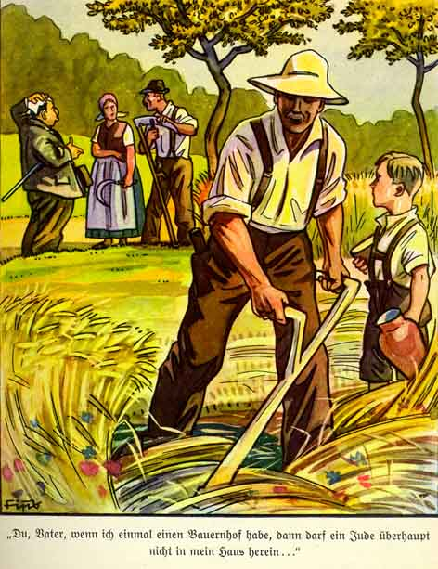
This story tells how a German peasant was driven from his land and farm by a Jewish financier, who, enforcing usurious interests, ruins the peasant and compels him to sell his farm. The picture shows the Jew in the background enforcing his claim, while in the fore a neighbouring peasant and his young son discuss what is taking place.
Little Paul is frightfully shocked. His eyes sparkle with anger. “What a mean Jew!” he says. Then he is silent awhile. Full of loathing, he looks at the Jew. He would like best to break the waterjug on the creature’s head. But what could the little fellow do! That would not help his neighbour.
“Father, when I am grown up and have a farm of my own, I will always think of our neighbour. And no Jew shall ever enter my house. I will write on the door : Jews prohibited! And if a Jew were to come in, I would at once throw him out!”
The Father nods:
“Right, Paul! One should have nothing to do with a Jew. The Jew will always cheat us. The Jew will take from us all we possess. Every peasant must make a note of that!”
“Yes,” says little Paul, “and I will always think of the saying which teacher has taught us at school:
’the peasant prays to the Lord:
Oh, keep the hail from us,
Protect us from lightning and flood,
Then we shall have again good harvest.
But worse than these plagues,
Never forget, is the Jews!
Be warned: Look out
For the bloodthirsty Jew!’”

Money is the God of the Jews

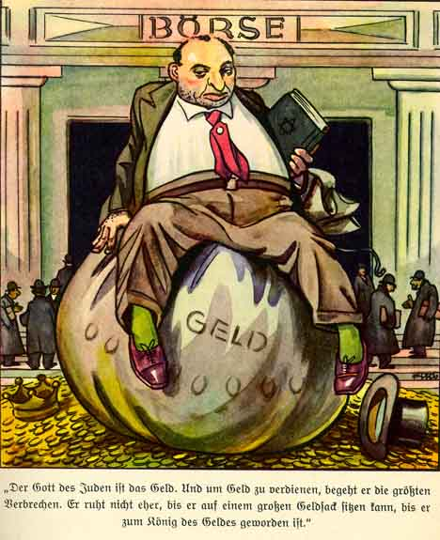
Liselotte looks out at the cottage window towards evening and talks to her mother about the hard way in which father has to work. She says:
“Do you know, mother, what I sometimes wish? I should like to be rich. Very rich! And with my money I would make people happy. I should love to help the poor!”
They go on talking. Liselotte asks:
“Tell me, mother, how does it happen that the Jews are so rich? Our teacher has told us at school that here are thousands of Jews in the world who are millionaires. And yet the Jews do not work. It is the Gentiles who must work. The Jew only trades. But one cannot become a millionaire by trading with paper, bones, old clothing and furniture!”
Mother explains how it is done.
“The Jew is quite indifferent when the cheated non-Jew goes hungry. Jews have no pity. They strive for one thing: — money. They do not care two hoots how they get it.”
Liselotte asks how they can behave in this mean way.
Mother answers:
“Child, one thing you must realise. The Jew is not a person like us. The Jew is a Devil. And a Devil has no sense of honour. A Devil deals only in meanness and crime. You have read your Bible, Liselotte. There it says the Jewish God once said to the Jews: ‘You must eat up the people of the earth!’ Do you know what that means? It means the Jew should destroy all other peoples. They should bleed and exploit them till they die. That is what it means.”
Liselotte tries to understand these things.
Mother continues:
“Yes, my child, that’s the Jew! The God of the Jews is gold. There is no crime he would not commit to get it. He has no rest till he can sit on the top of a gold-sack. He has no rest till he has become King Money. And with this money he would make us all into slaves and destroy us. With this money he seeks to dominate the whole world. All that is contained in the following saying:
’the Jew has only one idea in this world;
It is: Money, Money, Money!
By every kind of trick and device
To make himself immeasurably rich.
What cares he for scorn and contempt!
Money was and is his God!
Through money he hopes to lord it over us,
And achieve the mastery of the world.’ “

Are There Decent Jews?

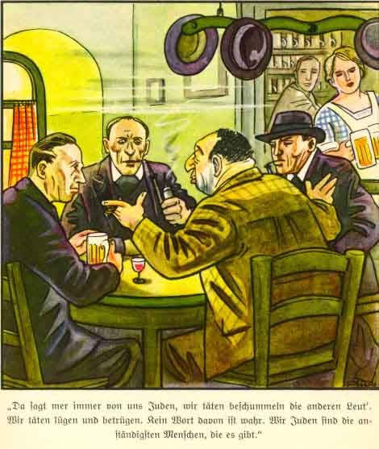
Four Germans sit talking in a public house. One is a Jew, Salomon, who is telling the others that the Jews are the most decent people to be found anywhere.
Zimmermann won’t have it and cites cases of Jewish rogues he has met.
The Jew gets uneasy, and seeks a way out by saying:
“Oh well, but those are exceptions!”
The peasant joins in the talk and supports Zimmermann.
“Salomon gets angry. He has paid for the beer and still must listen to that sort of talk from them.
“You talk a lot of stupid nonsense!” he cries, “but not a word about decent Jews. And there are plenty of decent Jews. Am I not one? Was I not a soldier at the front? Did I not defend the Fatherland. Have I not paid for your beer, you impudent creatures, stupid Gois!”
There is silence in the room. Then the worker gets up who has said little, and throws a coin to the Jew.
“Finished, Salomon. Here is your money. We will not have you paying for us. But now you shall have the truth! You liar! You never heard a bullet. You were ‘indispensable’ and stayed at home profiteering, then you were with the Reds, calling ‘Down with Germany!’ ‘Long live the World Revolution!’ And now you are a decent Jew? Not a bit of it! There aren’t any decent Jews.
Salomon picks up his hat and runs like the Devil from the public house. Everybody laughs.
“What a pity he has gone!” says mine host. “I should like to have repeated the following saying to him:
’so oft we hear the yarn
How brave such and such a few was.
How he gave his money to the poor
And was an angel in the world.
A Jew, like a pure angel?
That must be a fairy tale!
Who invents such things?
It is the Jew, himself, who does it!’”

