Name:
Date:
Parts of a Rocket

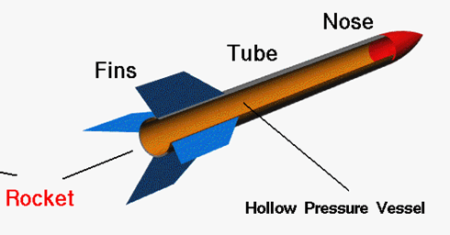
Nose

Body

Fins

