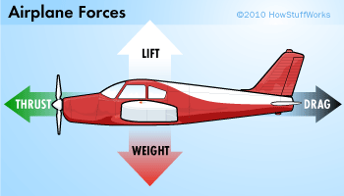
How Do Planes Fly: Thrust and Drag
Drop a stone into the ocean and it will sink into the deep. Chuck a stone off the side of a mountain and it will plummet as well. Sure, steel ships can float and even very heavy airplanes can fly, but to achieve flight, you have to exploit the four basic aerodynamic forces: lift, weight, thrust and drag. You can think of them as four arms holding the plane in the air, each pushing from a different direction.
First, let's examine thrust and drag. Thrust, whether caused by a propeller or a jet engine, is the aerodynamic force that pushes or pulls the airplane forward through space. The opposing aerodynamic force is drag, or the friction that resists the motion of an object moving through a fluid (or immobile in a moving fluid, as occurs when you fly a kite).
If you stick your hand out of a car window while moving, you'll experience a very simple demonstration of drag at work. The amount of drag that your hand creates depends on a few factors, such as the size of your hand, the speed of the car and the density of the air. If you were to slow down, you would notice that the drag on your hand would decrease.
We see another example of drag reduction when we watch downhill skiers in the Olympics. Whenever they get the chance, they'll squeeze down into a tight crouch. By making themselves "smaller," they decrease the drag they create, which allows them to zip faster down the hill.
A passenger jet always retracts its landing gear after takeoff for a similar reason: to reduce drag. Just like the downhill skier, the pilot wants to make the aircraft as small as possible. The amount of drag produced by the landing gear of a jet is so great that, at cruising speeds, the gear would be ripped right off the plane.
For flight to take place, thrust must be equal to or greater than the drag. If, for any reason, the amount of drag becomes larger than the amount of thrust, the plane will slow down. If the thrust is increased so that it's greater than the drag, the plane will speed up.

How Do Airplanes Fly: Weight and Lift
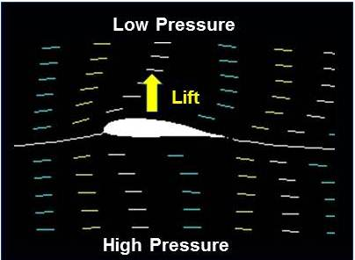
Every object on Earth has weight, a product of both gravity and mass. A Boeing 747-8 passenger airliner, for instance, has a maximum takeoff weight of 487.5 tons (442 metric tons), the force with which the weighty plane is drawn toward the Earth.
Weight's opposing force is lift, which holds an airplane in the air. This feat is accomplished through the use of a wing, also known as an airfoil. Like drag, lift can exist only in the presence of a moving fluid. It doesn't matter if the object is stationary and the fluid is moving (as with a kite on a windy day), or if the fluid is still and the object is moving through it (as with a soaring jet on a windless day). What really matters is the relative difference in speeds between the object and the fluid.
As for the actual mechanics of lift, the force occurs when a moving fluid is deflected by a solid object. The wing splits the airflow in two directions: up and over the wing and down along the underside of the wing.
The wing is shaped and tilted so that the air moving over it travels faster than the air moving underneath. When moving air flows over an object and encounters an obstacle (such as a bump or a sudden increase in wing angle), its path narrows and the flow speeds up as all the molecules rush though. Once past the obstacle, the path widens and the flow slows down again. If you've ever pinched a water hose, you've observed this very principle in action. By pinching the hose, you narrow the path of the fluid flow, which speeds up the molecules. Remove the pressure and the water flow returns to its previous state.
As air speeds up, its pressure drops. So the faster-moving air moving over the wing exerts less pressure on it than the slower air moving underneath the wing. The result is an upward push of lift. In the field of fluid dynamics, this is known as Bernoulli's principle.

Aerial Navigation: Wings, Slats and Flaps
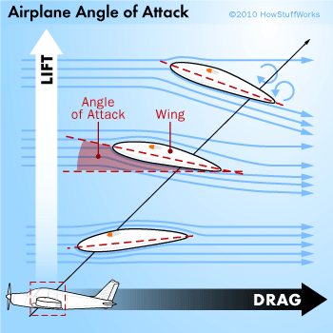
Having covered the basic physics of flight and the ways in which an airplane uses them to fly, the next obvious step is to consider navigation. How does an airplane turn in the air? How does it rise to a higher altitude or dive back toward the ground?
First, let's consider the angle of attack, the angle that a wing (or airfoil) presents to oncoming air. The greater the angle of attack, the greater the lift. The smaller the angle, the less lift. Interestingly enough, it's actually easier for an airplane to climb than it is to travel at a fixed altitude. A typical wing has to present a negative angle of attack (slanted forward) in order to achieve zero lift. This wing positioning also generates more drag, which requires greater thrust.
In general, the wings on most planes are designed to provide an appropriate amount of lift (along with minimal drag) while the plane is operating in its cruising mode. However, when these airplanes are taking off or landing, their speeds can be reduced to less than 200 miles per hour (322 kilometers per hour). This dramatic change in the wing's working conditions means that a different airfoil shape would probably better serve the aircraft. Airfoil shapes vary depending on the aircraft, but pilots further alter the shape of the airfoil in real time via flaps and slats.
During takeoff and landing, the flaps (on the back of the wing) extend downward from the trailing edge of the wings. This effectively alters the shape of the wing, allowing it to divert more air, and thus create more lift. The alteration also increases drag, which helps a landing airplane slow down (but necessitates more thrust during takeoff).
Slats perform the same function as flaps (that is, they temporarily alter the shape of the wing to increase lift), but they're attached to the front of the wing instead of the rear. Pilots also deploy them on takeoff and landing.
Pilots have to do more than guide a plane through takeoff and landing though. They have to steer it through the skies, and airfoils and their flaps can help with that, too.

Name:
Date:
How Do Airplanes Fly?

Directions: Answer the following questions as you read the article.

- What are the four basic aerodynamic forces you need to fly?
- What is thrust?
- What is drag?
- What are the factors drag depends on?
- What must occur for flight to take place?
- Weight is a product of what two things?
- What is lift?
- What really matters when trying to generate lift?
- In your own words, explain how a wing generates lift.
- What is Bernoulli’s principle?
- What is the angle of attack?
- Why is it easier for an airplane to climb than travel at a fixed altitude?
- How do flaps alter the shape of the wing?
- How are slats different from flaps?
- Other than takeoff and landing, how do flaps and slats help a pilot while flying?

