Exhibit A: A Flying Machine, 1490
This image shows the internal design of a wing. Notice how the internal ribbing mirrors the skeletal structure of a bat’s wing.

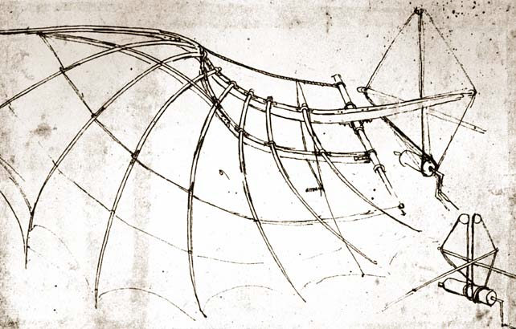

Exhibit B: Birds in Flight
Da Vinci’s drawings of birds in flight show the different positions of birds’ bodies as they travelled through the air. Leonardo drew a great deal of inspiration for his early flying machines from birds’ wings.

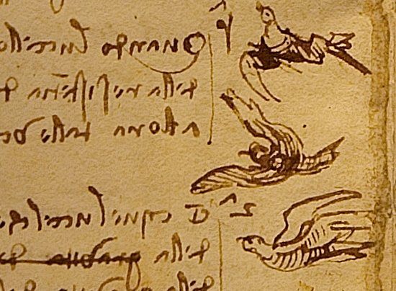
Exhibit C: Design of a Wing
Leonardo’s wing was designed to be flexible. This allowed the pilot to flap the wings to generate the needed lift, much like a bird.

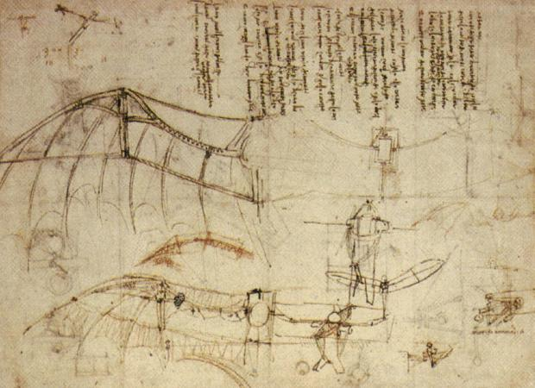
Exhibit D: Articulated Wing Joints
The articulated joints mirror the internal structure of the wings of birds and bats.

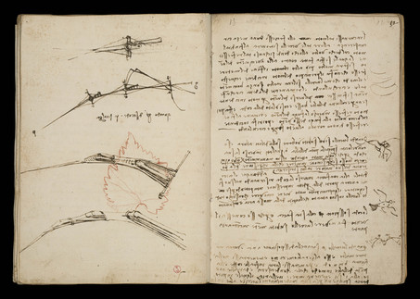
Exhibit E: Drawing of a Wing
Leonardo spent a great deal of time studying the anatomy of wings. He designed his wings to mirror that of a bird. By copying the internal and external structures of nature’s wings he attempted to adapt human physiology to flight.

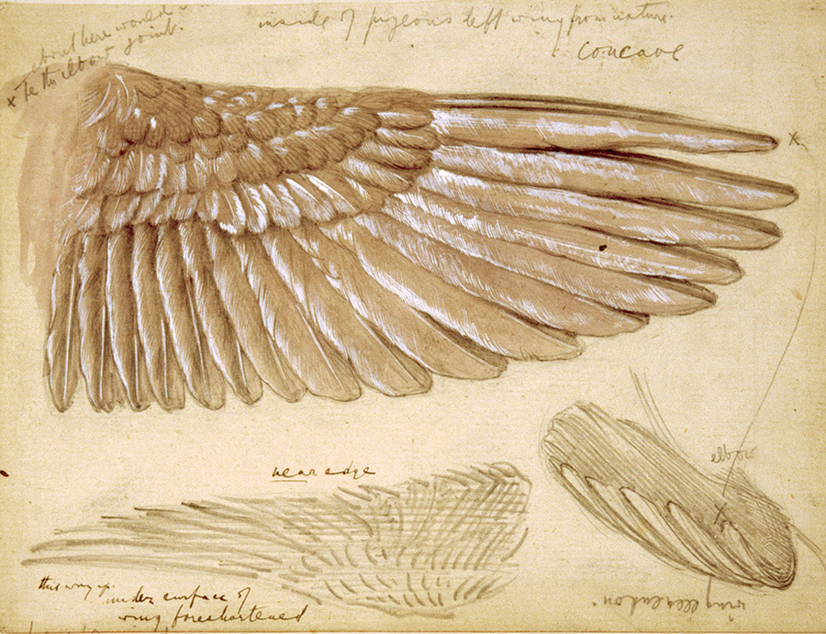
Exhibit F: Ornithopter Design
Below is the design for Leonardo’s Ornithopter. The wings were designed to flap similar to a birds’ wings as the pilot rode in a prone position.

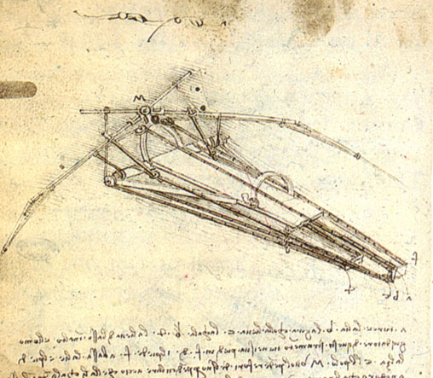
Exhibit G: Da Vinci Parachute

Leonardo’s parachute was designed to catch the air and slow the pilot’s descent.
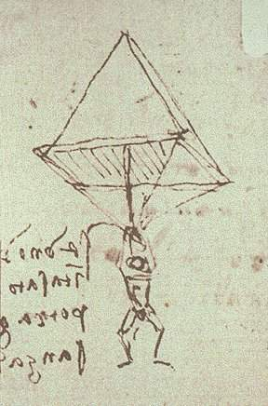

Exhibit H: Leonardo’s “Aerial Screw”
This is a design for an early helicopter. It is designed to generate lift by pulling through the air similar to how a screw will pull itself through a wooden plank.

