African Jewelry Project

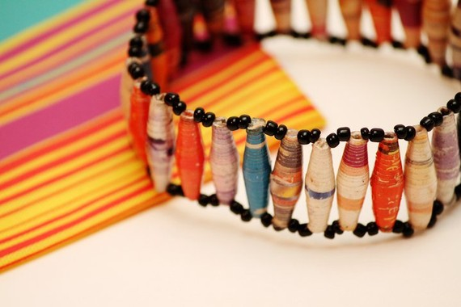
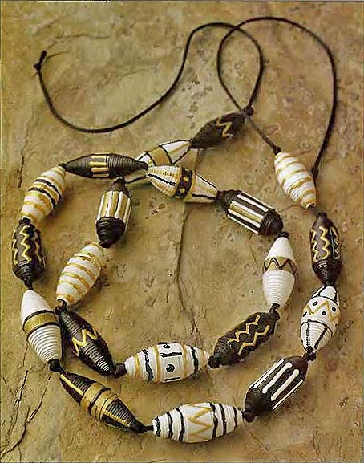

- Using a ruler, pencil, and pair of scissors; cut out triangular or rectangular strips of cardstock to make patterns for your beads. “Rugby Ball” – length 40 cm, width 3 cm narrowing to 6 mm, “Barrel” – length 45 cm, width 3 cm narrowing to 1.5 cm, “Little Hat” – length 15 cm, width 8 cm (see image below). Feel free to be a bit more creative with your beads in terms of width and length; the measurements are just guides to get you started.
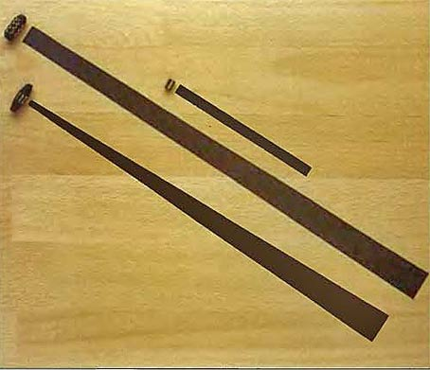
- Trace out several beads using the templates you just made. Cut them out using scissors.
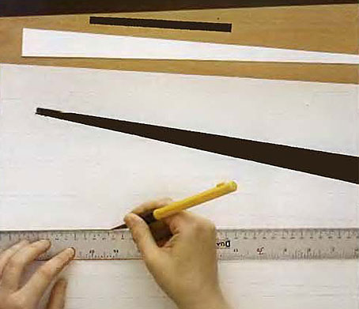
- Decorate one side of your strip and curl each strip with scissors to make it easier to work with.
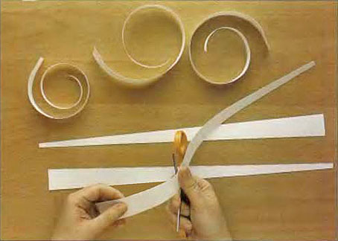
- Wrap the strips around a wooden skewer or toothpick to create the bead. Place a bit of glue on the end and secure. Repeat these steps to make several beads.
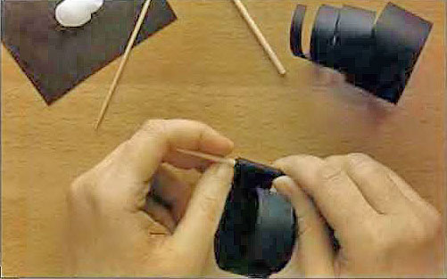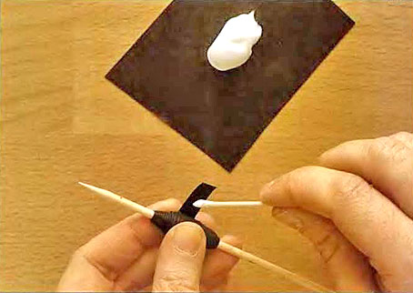
- Once dry, apply a thin coat of varnish to help make the beads water resistant. Allow to dry.
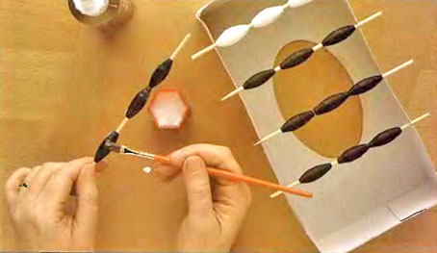
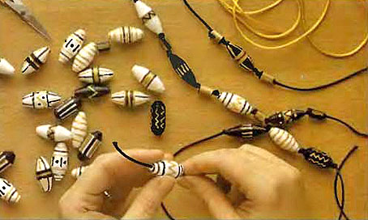
- Decorate however you choose, string together, and enjoy.
